

Analyzing and Visualizing Data with Excel

Lab 1

# Overview

In this lab, you will explore an Excel report that has a dashboard created using native Excel charts and slicers based on data from Excel sheets. You will then extend the dashboard by adding a pivot table with slicer and apply conditional formatting to the pivot table.

Before starting this lab, you should view **Module 1** in the Course *Analyzing and Visualizing Data with Excel*. Then, if you have not already done so, follow the instructions in the **Getting Started** document for this course to set up the lab environment.

# What You’ll Need

* A computer with Microsoft Excel installed on it. We prefer Excel 2016, but you can still complete the lab using Excel 2013 or Excel 2010.
* File “Module 1 – classic analysis.xlsx”

# Challenge 1: Explore the Classic Excel Dashboard

Download and open “Lab 1 – classic analysis.xlsx”. You should see 3 charts showing Sales by color, Sales by country, and Revenue & Profit Margin %.

## Answer the following question by reviewing the data source

1. Where does the sales figure shown in the chart come from?
2. Where does the product category and subcategory mapping come from?

# Challenge 2: Extend the Classic Excel Dashboard

## 1. Add a New Pivot Table to the Dashboard

Create a new pivot table based on the Sales table. Build the pivot table with the following properties:

* Sum of Amount and Sum of Margin% as values.
* Format Margin% as Percentage.
* Product color as Rows.

Where does the Margin% calculated field come from?

Note that the Margin% for the total row is the average because Margin% is not additive.

## 2. Add Filtering capabilities

Create a new slicer based on Years and connect it to the existing charts.

Connect the existing slicers to this new pivot table.

How many connections does the Years slicer have?

## 3. Apply Conditional Formatting

Apply conditional formatting of Green – Yellow – Red Color Scale to all cells showing Sum of Margin% values.

Apply conditional formatting of Green Data Bar to all cells showing Sum of Amount values for Product Color.

Why select a different option for the second conditional formatting?

Your extended dashboard should look as follows:

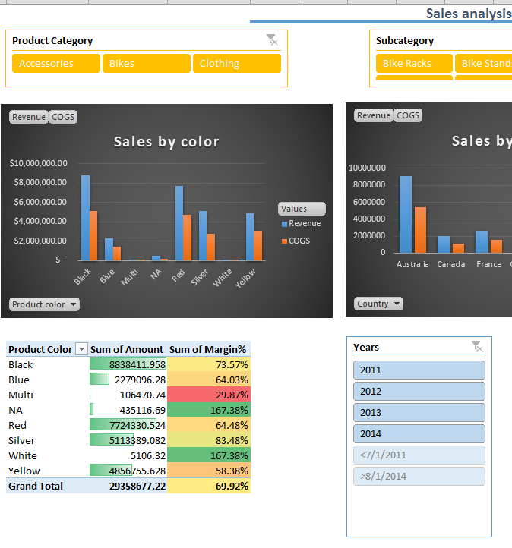

# Next Steps

Well done! You’ve completed the lab, and you’re ready to continue to **Module 2** in the Course *Analyzing and Visualizing Data with Excel*.